Floyd Mayweather Fans site Report

Student Name: Olanrewaju Eniola
Course: Business IT with Software Applications and Web Design
Module: Web Authoring
Website Used: dzineblog.com and dunnesstores.com

Name of site: www.floydmayweatherfans.com
Type of site: Sport
Site Objectives and Target Audience: This website will deliver the latest news, pictures, events, upcoming fight of Floyd Mayweather.
Access Speed: Pages under 15kb for quick access.
Colour and Aesthetics: Black/Green
Page Layout:
Home Page – Contains pictures of Floyd Mayweather fighting with different boxers and also the banner of his fight with Manuel Marquez.
Biography: It contains short biography of Floyd Mayweather and his picture.
News: Contains the picture of Floyd Mayweather with the collections of title belt and it also has the picture of the boxer people are asking him to fight to show that he is champion.
Video: This page contains video of Floyd mayweather.
Store: It contains different T-shirt pictures, HBO banner and Adidas banner.
Gallery: Contains pictures of Floyd Mayweather himself with his pals or when he was fighting.
Contact: It contains forms and links to different social site where you can keep abreast with what Floyd Mayweather is up to.
Sitemap: This contains links to pages in the website.

Navigation Structure:
- Home Page – index.html
- Biography – biography.html
- News – news.html
- Video – video.html
  - Video1.html
  - Video2.html
  - Video3.html
  - Video4.html
  - Video5.html
  - Video6.html
- Store – store.html
- Gallery – gallery.html
  - Gallery1.html
  - Gallery2.html
  - Gallery3.html
  - Gallery4.html
  - Gallery5.html
  - Gallery6.html
- Contact – contact.html
- Sitemap – sitemap.html

Site Code: XHTML 1.0 Transitional / CSS
Design Hardware and Software:
Maxdata PC – Windows XP 1gb RAM
Macromedia Dreamweaver
Google chrome

Production Plan
Week One: Mon – Initial research + content gathering (Text + Image)
Wed – Initial design – Laying out my page + site.
Week Two: Mon – Development in Dreamweaver
Wed – Home page design – Tables
- Graphics
- Links
- Meta Data
- CSS
Week Three: Mon – Development in Dreamweaver – Contact Us
Wed – Forms – You Tube Videos.
Week Four: Mon – Finishing Site
Wed – Test

Project Log:
Week One: I started the designing of the website. I first look at other sports website for guideline and started putting together the text and images together. I have the layout of the home page drawn on Monday during the class.
Week Two: I started using Dreamweaver. I put Mayweather banner picture in the home page. Put the picture of Mayweather’s fights on the home page and also the text.
Week Three: I completed the designing of home page during Monday class. I almost finished the other pages after Wednesday class
Week Four: I completed the designing of the website and just looking out to make it look perfect.

Home

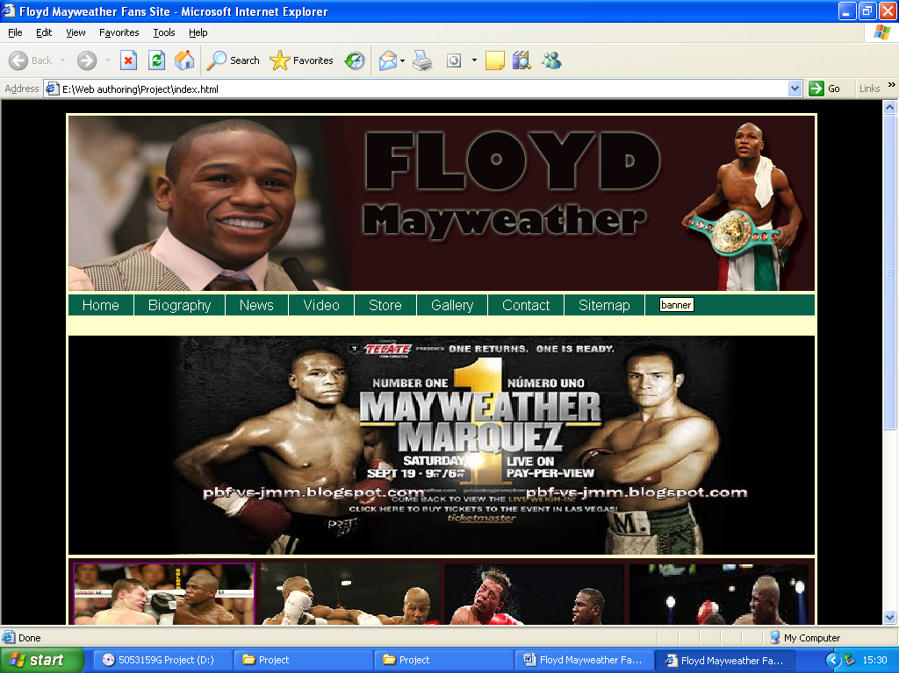
I

Store
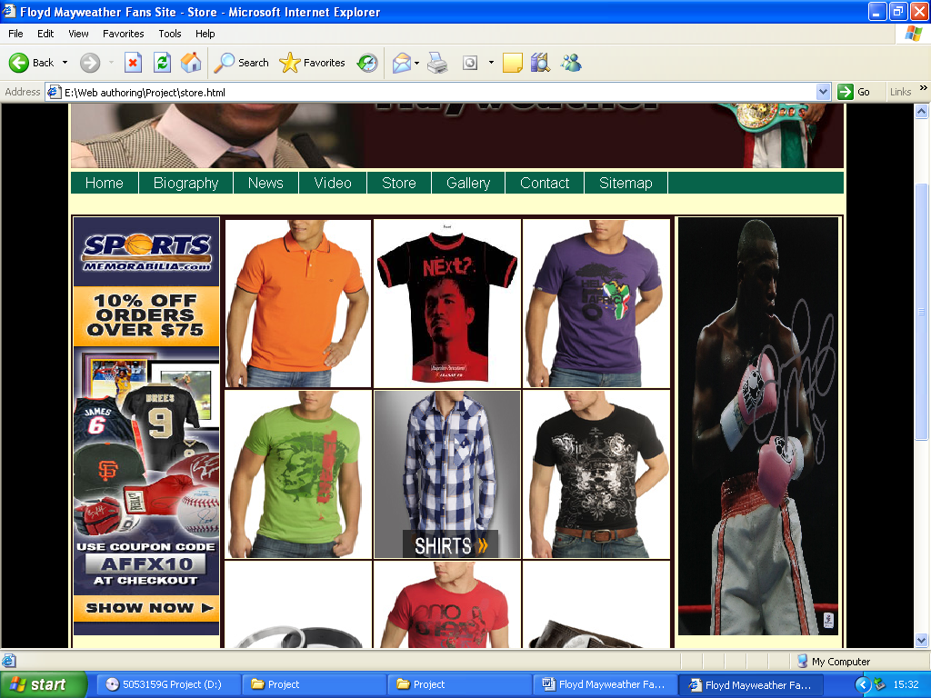

Gallery
